

**Senior Design Project Report**

**COMP491**

Atakan Ermete, 041601023

Muhammed Rahmetullah Kartal, 041701008

Zeynep Ayyüce Çay, 041601021

Advisor: Tuna Çakar

2021

**MEF UNIVERSITY**

**FACULTY OF ENGINEERING**

**DEPARTMENT OF COMPUTER ENGINEERING**

Project Title : Artificial Intelligence Supported 2D Story-Driven Video Game

Student(s) Name : Atakan Ermete,

Muhammed Rahmetullah Kartal,

Zeynep Ayyüce Çay

Date : 21/01/2021

I hereby state that the design project prepared by Your Name (Title Format) has been completed under my supervision. I accept this work as a “Senior Design Project”.

dd/mm/yyyy

Tuna Çakar

I hereby state that I have examined this senior design project by Your Name (Title Format). This work is acceptable as a “Senior Design Project”.

dd/mm/yyyy

Department Chair’s Name

Head of the Department of

Computer Engineering

**ACADEMIC HONESTY PLEDGE**

In keeping with MEF University Student Code of Conduct, I pledge that this work is my own and that I have not received inappropriate assistance in its preparation. I further declare that all resources are explicitly cited.

NAME DATE SIGNATURE

Atakan Ermete 21/01/2021

Muhammed Rahmetullah Kartal 21/01/2021

Zeynep Ayyüce Çay 21/01/2021

**ABSTRACT**

ARTIFICIAL INTELLIGENCE SUPPORTED 2D STORY-DRIVEN VIDEO GAME

Atakan Ermete

Muhammed Rahmetullah Kartal

Zeynep Ayyüce Çay

MEF UNIVERSITY

Faculty of Engineering

Department of Computer Engineering

Advisor: Tuna Çakar

JANUARY 2021

Unlike the common 2D story-based games that are in today's game market, the aim is to bring a different perspective to the market by supporting the in-game quests with Artificial Intelligence (AI) and multiple decisions made by the player during the game to set in an imaginary world, this game is a story-driven 2D RPG, so to add a new viewpoint to the game industry by encouraging different algorithms of AI in in-game quests and story flow according to the player's decisions is the most important part, and applying that idea in a 2D story-driven game is the project’s must. In this imaginary world, the player is going to play the game as an American army soldier against Nazi Germany in Second World War and going to understand cruelty in world events.

**Keywords:** 2D, Story flow, AI, Role Play Game (RPG)

# TABLE OF CONTENTS

ABSTRACT 4

TABLE OF CONTENTS 5

LIST OF TABLES 7

LIST OF FIGURES 8

1. INTRODUCTION 11

1.1. Motivation 11

1.2. Content 11

1.3. Artificial Intelligence 11

1.4. Economic Aspects 11

1.5. Impact 11

1.5.1. Global Impact of the solution 11

1.5.2. Economic Impact of the solution 12

1.5.3. Societal Impacts of the solution 12

2. PROJECT DEFINITION AND PLANNING 12

2.1. Project Definition 12

2.2. Project Planning 12

2.2.1 Aim of the Project 12

2.2.2 Story 12

2.2.3 Quest Types 14

2.2.4 Project Time Planning 18

2.2.5 Success Criteria 21

2.2.6 Project Time and Resource Estimation 21

2.2.7 Risk Analysis 21

2.2.8 Tools Requirements 22

3. THEORETICAL BACKGROUND 22

3.1. Literature Survey 22

3.2. Solution Method 22

4. ANALYSIS AND MODELLING 23

4.1. System Factors 23

4.2. How System Works 23

4.3. Modelling and System Architecture 23

5. DESIGN, IMPLEMENTATION AND TESTING 26

5.1. Design 26

5.2. Implementation 26

5.3. Testing 26

6. RESULTS 27

7. CONCLUSION 28

7.1. Life-Long Learning 28

7.2. Professional and Ethical Responsibilities of Engineers 29

7.3. Contemporary Issues 29

7.4. Team Work 29

8. REFERENCES 30

9. Appendix 31

# LIST OF TABLES

Table 1. The event done by group members 18

Table 2. The events is going to be done by group members 19

# LIST OF FIGURES

Figure 1. First move of Isolation Game 16

Figure 2. Second move of Isolation Game 16

# INTRODUCTION

## Motivation

The main motivation to start this project is the group member's desire to create a game and a story due to their imaginations. Group members chose to different unique game to the game market because of they had an idea about the games available on the market. It is determined to design a 2D story-based game using artificial intelligence in mini quests and storyline. The biggest difference of the this game from game market is that it contains 2-dimensional and artificial intelligence tasks by story-based.

## Content

The content is designed to express the effects of war on human psychology and ideas. To make feel better these effects game and environments going to be designed in different parts, the first part takes the middle of the war, consequently the problems that it causes as the topic from the perspective of a soldier, in the continuation of the story the psychological effects and disappointments of the first episode is dealt with, at the end of the fiction with the concreted emotions which are decided by the player, the alternative endings came up. Decisions will impress the player as the whole fiction continues as a main story.

## Artificial Intelligence

The role of AI in the game is to give a challenge to players on the different side and main quests like the 3x3 isolation game. Almost all these quests are going to be compulsory to achieve full progress in the story, and the level of AI is going to change related to the player’s decisions and play style. There are some side quests in the main story. Since these quests will affect the flow of the storyline, it is the player's decision to do it or not. In the side mission called Connect-four, the user has to win the game against artificial intelligence. Otherwise, player can not able to see the possible consequences because of the chest quest not completed. In another task, the user has to finish the randomly determined maze with the luck factor(dices) before the artificial intelligence. The luck factor has been developed so that it is possible for the user to defeat artificial intelligence. In the last part of the game, the user have to play a 3x3 isolation game to finish and see alternative end scenes by completing story. He must complete the tasks within the specified time and make the necessary move for the isolation game. Otherwise, the user cannot defeat the artificial intelligence. The purpose of artificial intelligence is to enable the user to perform tasks in a difficult way and to restrict freedom of movement. The user will face this and similar artificial intelligence tasks many times.

## Economic Aspects

Due to the consensus of the group members the project doesn’t have an economic income expectation, the main idea is launching the game on different computer platforms and to be accessible by other players.

## Impact

* + 1. **Global Impact of the Solution**

The global impact of this project, we have done is that people play this game. Because as the number of people playing this game increases, the rate of people being talked about will increase and will begin to attract people's attention. Being popular in the market causes the number of such games to increase. Users mostly like to experience new games. The aim of this project is to provide users with new experiences.

* + 1. **Economic Impact of the Solution**

The project will allow players to get a new and different experience for free. Therefore, the project does not make any economic contribution. But even though it does not have an economic impact, it has innovative effects on the game market in many areas. Only by increasing the popularity of the game environments we have installed has contributed to those environments.

* + 1. **Societal Impact of the Solution**

An example of the societal impact of the project can be the negative factors such as the stress experienced by the individuals who play during the day by enjoying this game. Having fun while playing this game is among the main goals. Since the game is not online, there will be no social communication. However, the fact that people talk about alternative endings by verbally communicating and changing the flow of the game based on these can be an example of the social effect of the game.

# PROJECT DEFINITION AND PLANNING

## Project Definition

This game is a story-driven 2D RPG set in an imaginary universe. In the game, you play as a soldier of the American army against Nazi Germany in WW2 to complete quests in the story to reach multiple endgame scenarios. The decisions of the user are important because they affect the storyline and Artificial Intelligence in quests. These choices are very important as the game strategy of artificial intelligence will change according to the user's decisions.

## Project Planning

## Aim of the Project

The aim is serving a new perspective to gaming industry by implementing an AI supported, story-based 2D game. The role of AI in this aim is giving an extra challenge to player and force him/her to make correct decisions. Story-based 2D games are almost nonexistent in the game market. This project is created in order to bring a different area to the game market. At the same time, it is free also it aims for users to experience different experiences in a free and easy way.

## Story

The first scene starts with hope about the end of the war, soldiers are talking about that situation, but all hope ends with a sudden attack on the second facade of the American Army which is inside the Nazi Germany area, this facade doesn’t have concrete buildings. Before that attack soldiers are training in different zones of the facade, this scene is about basic quick tips about playstyle and conversations of our two main characters (old man [Gerard] and young one [Sam]), on these conversations Sam realizes that Gerard has some problems about remembering things, because of that he gives a photo of himself to Gerard in that day.

On the night of the day that attack happens by enemy planes, as soon as Sam wakes up, he runs out of the tent checks for Gerard’s tent, and realizes that he is missing, after that he tries to help other soldiers and sees the injured commander, takes command from him, and starts his first actual quest about ringing the alarm and communicating the third facade about the situation.

After finishing these quests and saving people, Sam still worries about Gerard and returns to the second facade which is officially under the invasion of the enemy, in some area that is close to that facade he finds Gerard. Gerard remembers him and talks about the plan he made for that they need to split up, this part has two different stories for each main character, and we are going to play them one by one, also they will have quests together.

In the middle of this plan, enemy soldiers notice our main characters and start shootings, one of the characters is going to be shot but the screen will be almost fully blurred, and we won’t be able to see who is shotted.

After a while we are going to play with Gerard while he is running away from the area without Sam, after some time he will be out of breath and going to faint in a secure place, then we will see that Sam got shot and the enemy soldiers around the body, they will leave him by thinking he is dead. When they are gone, he will wake up with an injured body and goes to a German city after changing his uniform. Besides all that he thinks that Gerard has left him and run away, but at the same time he thinks if he is on Gerard's foot, he will probably do the same thing.

The main story starts in the German city, Sam is going to try to get himself a new life, he is going to work in a casual job, with the time he will get the news about the end of the war and the victory of Germany, he is going to fall in love with a girl named Elizabeth in this period. With some of the side and main quests, he can be able to find gifts for Elizabeth or useful goods for himself, for example after a game against ai in the city tavern, if he can do enough success against ai he will get two tickets for a prom, on this prom scene we are going to see how their relationship is going to move on (player will decide that by his/her decisions).

In some of the parts, Sam will realize that he is not able to do some of the things that he can do before that injury, but he won’t mention this situation to anyone. After all these, it will come out that Elizabeth’s father is one of the commanders which saw Sam’s dead body, but he won’t understand that because time passed and changes on Sam.

One day Elizabeth mentions a man, which his father trying to catch, to Sam and shows the photo of him, after a little shock Sam realizes that the person in the photo is himself, then starts thinking about Gerard, he thinks Gerard is probably captured by the enemy and they took his photo from Gerard’s backpack.

Because of recent events Sam decides to avenge and does little sabotage operations while everything was on the rail. After a couple of successful sabotages Elizabeth’s father understands that Sam is responsible for all that, but he doesn’t reveal this situation. At the end of all these sabotages Sam decides that he did take revenge on Gerard, but it is too late for everything because Elizabeth’s father threatens Sam, with his own daughter’s life. This is the last decision of the game, the player can save Elizabeth but not Sam, can lose both or save both, it is all about understanding the trick in the story, because all the scenes, including Sam’s first injury, is a dream of Gerard, actually we are playing Gerard’s ideas in Sam’s body. There will be more signs to make the player realize that everything is a dream

## Quest Types

### • Main Quests

These quests are mandatory to pass levels and will be in interaction with the main story. In the current situation we are going to talk with the commander, will take a quest about connecting the parts of broken bell and ringing the bell. While in this quest we need a shovel and dig the rubbles those are blocking our way. For this operation we need a save system between scenes and currently working on save system.

### • AI Oriented Quests

One of the most important part of the game is AI because they will be the actual challenges, as we mentioned in the introduction.

***Connect Four Game and Implementation:***

Connect four is a two-player connection-based board game. In this game players select a color and try to connect four of these same-colored discs vertically, horizontally or diagonally into a seven column, six row grids. The piece placement mechanic is like each piece fall straight and occupies the lowest place in the column. By the correct moves, starter player can always win [1].

As said before, we are fighting against Nazi Germany, they have an encryption machine named Enigma, the main idea in this machine is creating an encryption system to hide messages in the war [2], in our implementation instead of encryption there will be a lock in a box, to collect the loot of box we need to win against a four-connect AI. There are three possible levels in the AI, first one will be almost perfect, it always does the correct moves, if player loses first round box is going to be damaged and game will restart with a lower-level AI, if player loses again box is going to get another damage and game will restart with an AI that is programmed to lose, in this level box is going to be opened whether player loses or wins.

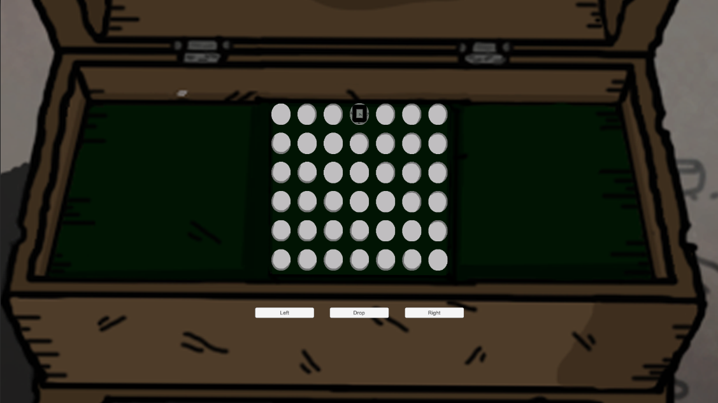

**Figure 1:** Connect Four In-Game

The coding part have two different aspects, first one is unity coding for one versus one gameplay, the 6x7 grid can be seen in Figure 1, with the help of Left, Right and Drop buttons we can place our pieces, AI is going to move after each move of us. The square piece in the center top of screen shows where we are going to play next.

For the piece placement there are two 1D arrays, one of them is to store rows, the other one is to store columns, in the beginning column array is filled with “5” s. The reason behind this “5” values assignment is simulating piece fall down effect. There is a 1D array which contains 42 different white circles as images, to put a piece in the board, we are changing the image sprite of corresponding place. To detect the corresponding place in the unity screen, coordinates are being used.

To implement artificial intelligence, alpha-beta pruning algorithm is used. It is a depth-first tree search algorithm which is an optimized version of minimax algorithm, the main idea is stopping the evaluation of current move if there is a possibility that proves move is worse than the previous one. [3]

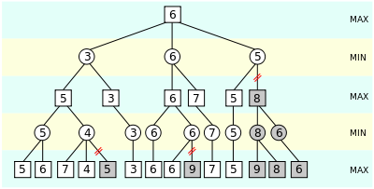

**Figure 2:** Alpha-Beta Pruning Illustration [3]

As we can see in Figure 2, gray subtrees are eliminated because there is no need to evaluate them again and again, like in the second left, it is obvious that algorithm will select “5” as second maximizing node, so in the second bottom left subtree after finding “4” next ones aren’t important.

The heuristic calculations are done with a different method, main idea of the method is gathering continuous vertical, horizontal and diagonal places as windows that are sized 4 and checking these window places like how many of them are corresponding to AI, player and empty pieces. For example, if AI can ensure all four of them are AI places, it will add 100 points to its score, or three of them are corresponding to opponent and last one is corresponding to an empty space, it will subtract 5 points from its score.

All the score calculations, winning conditions and algorithm implementations is done in a 2D, 6x7 array because unity gameObject sprite changes and controls take time, so in order to save time AI pieces numbered as “2”, player pieces numbered as “1” and empty places assumed “0”, instead of changing sprites of each image on each iteration, we can basically change the array elements in the minimax algorithm and at the end change the sprite of correct place.

As said before, alpha-beta pruning is an improved version of minimax, so main idea of minimax is maximizing AI move scores while minimizing the enemy scores. In the first condition algorithm checks is the current move a terminal, in other words finishing move, if it is a terminal and AI is winning, it returns a max score for AI, if player is winning it returns min score for AI, if there is a tie situation, returns zero.

Since minimax is a recursive algorithm, it will call itself until becoming a terminal node and in each recursion operation it creates a clone of current board and adds its move to that, by doing this it prevents doing wrong operations in main board.

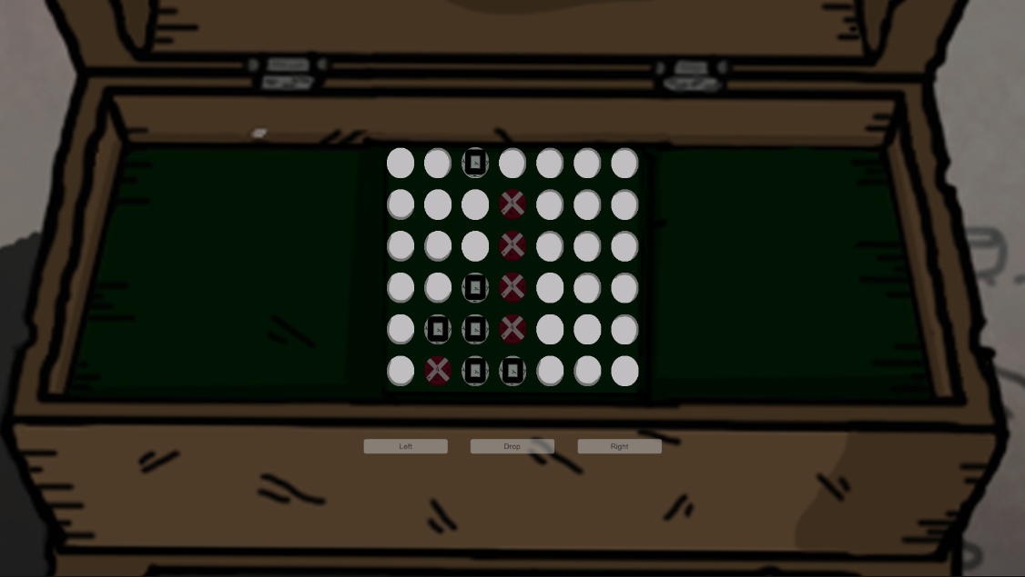

**Figure 3:** Four Connect In-game AI is Winner

We can see the winning situation in Figure 3, currently after first lose of player, buttons are becoming non-interactable.

***Labyrinth Game Idea:***

Currently team is working on a labyrinth game that player is going to play in a tavern. Player is going to sit next to someone in the tavern and the opponent will create a random labyrinth by putting wooden barricades in a squared zone. After preparing the area opponent will select start and end zones. In the beginning algorithm will use A* search to find the correct path, after finding the path it will store the coordinates.

Game is going to be one vs one, and each player is going to try to solve the maze. At the start of the game player will roll two dices and will have sum of dice values moves, for example if dices are 1 and 2, player will be able to play 3 squares, same situations are going to be applied to AI, besides those, player will have a limited time for each move for extra challenge.

Since A* is an informed search algorithm we need start and ending position, that is why enemy is selecting start and ending positions, algorithm works like checking the lowest cost while searching next values by checking heuristics.

***Isolation Game Idea:***

Main idea of the game is making the enemy unable to move in a 3x3 grid. For this operation alpha-beta pruning is going to be used as like the connect four game. To make a move, player must play a basic mini game like remembering a number sequence, these games won’t be based on AI. Each move of player will sabotage a part of a building, while player sabotaging zones AI is going to try to prevent him by doing its moves.

## Project Time Planning

Table 1: The events done by group members

|  |  |  |  |  |  |  |  |  |  |  |  |  |  |  |  |  |
| --- | --- | --- | --- | --- | --- | --- | --- | --- | --- | --- | --- | --- | --- | --- | --- | --- |
| **Task** | **Responsible Person** | **Weeks** | | | | | | | | | | | | | | |
| **1** | **2** | **3** | **4** | **5** | **6** | **7** | **8** | **9** | | **10** | **11** | **12** | **13** | **14** |
| Character Drawing | Zeynep Ayyüce Çay |  |  |  |  |  |  |  |  |  |  | |  |  |  |  |
| Muhammed Rahmetullah Kartal |  |  |  |  |  |  |  |  |  |  | |  |  |  |  |
| Atakan Ermete |  |  |  |  |  |  |  |  |  |  | |  |  |  |  |
| Background Drawings | Zeynep Ayyüce Çay |  |  |  |  |  |  |  |  |  | |  |  |  |  |  |
| Items to be Drawn in the Environment | Zeynep Ayyüce Çay |  |  |  |  |  |  |  |  |  | |  |  |  |  |  |
| Atakan Ermete |  |  |  |  |  |  |  |  |  | |  |  |  |  |  |
| Items That Need to Be Scratched Inside the Tent | Zeynep Ayyüce Çay |  |  |  |  |  |  |  |  |  | |  |  |  |  |  |
| Atakan Ermete |  |  |  |  |  |  |  |  |  | |  |  |  |  |  |
| Animations of Characters and Environment | Muhammed Rahmetullah Kartal |  |  |  |  |  |  |  |  |  | |  |  |  |  |  |
| Designing the Scenes in Unity | Muhammed Rahmetullah Kartal |  |  |  |  |  |  |  |  |  | |  |  |  |  |  |
| Coding and Testing | Muhammed Rahmetullah Kartal |  |  |  |  |  |  |  |  |  | |  |  |  |  |  |
| Report and Project Presentation | Zeynep Ayyüce Çay |  |  |  |  |  |  |  |  |  | |  |  |  |  |  |
| Muhammed Rahmetullah Kartal |  |  |  |  |  |  |  |  |  | |  |  |  |  |  |
| Atakan Ermete |  |  |  |  |  |  |  |  |  | |  |  |  |  |  |
|  |  |  |  |  |  |  |  |  |  |  |  |  |  |  |  |  |

In the project, the things done in the past are as follows.

* First, the important characters were drawn. However, most of these drawings have been redrawn in their original versions. Then, the animations of these drawings were made for each character. However, the animations of the characters contain the animations so far. Then the required animations will be made as the game progresses.
* Necessary items were drawn in the environment. Then the main image was created by drawing the background. The adjustments of this scene were made through unity and the main character was placed. Codes were written in unity to create and combine these scenes.
* After the functions of the first scene were finished, the production of the scenes inside the tents and the tower was started. First, the backgrounds and the necessary items were drawn. By combining these drawings on unity, many scenes have been obtained.
* To pass between these scenes, codes were written on the unity and the transition of the actor was provided.
* These drawings, animations, and scenery are the first part of the game.

Table 2: The events are going to be done by team members.

|  |  |  |  |  |  |  |  |  |  |  |  |  |  |  |  |  |  |
| --- | --- | --- | --- | --- | --- | --- | --- | --- | --- | --- | --- | --- | --- | --- | --- | --- | --- |
| **Task** | **Responsible Person** | **Weeks** | | | | | | | | | | | | | | |  |
| **1** | **2** | **3** | **4** | **5** | **6** | **7** | **8** | **9** | | **10** | **11** | **12** | **13** | **14** | **15** |
| Character Drawing | Zeynep Ayyüce Çay |  |  |  |  |  |  |  |  |  |  | |  |  |  |  |  |
| Muhammed Rahmetullah Kartal |  |  |  |  |  |  |  |  |  |  | |  |  |  |  |  |
| Atakan Ermete |  |  |  |  |  |  |  |  |  |  | |  |  |  |  |  |
| Background Drawings | Zeynep Ayyüce Çay |  |  |  |  |  |  |  |  |  | |  |  |  |  |  |  |
| Items to be Drawn in the Environment | Zeynep Ayyüce Çay |  |  |  |  |  |  |  |  |  | |  |  |  |  |  |  |
| Atakan Ermete |  |  |  |  |  |  |  |  |  | |  |  |  |  |  |  |
| Animations of the Characters | Zeynep Ayyüce Çay |  |  |  |  |  |  |  |  |  | |  |  |  |  |  |  |
| Atakan Ermete |  |  |  |  |  |  |  |  |  | |  |  |  |  |  |  |
| Environment Animations | Muhammed Rahmetullah Kartal |  |  |  |  |  |  |  |  |  | |  |  |  |  |  |  |
| Designing the Scenes in Unity | Muhammed Rahmetullah Kartal |  |  |  |  |  |  |  |  |  | |  |  |  |  |  |  |
| Designing Normal Tasks in Game | Zeynep Ayyüce Çay |  |  |  |  |  |  |  |  |  | |  |  |  |  |  |  |
| Atakan Ermete |  |  |  |  |  |  |  |  |  | |  |  |  |  |  |  |
| Designing In-Game AI Tasks | Zeynep Ayyüce Çay |  |  |  |  |  |  |  |  |  | |  |  |  |  |  |  |
| Atakan Ermete |  |  |  |  |  |  |  |  |  | |  |  |  |  |  |  |
| Coding AI Tasks | Muhammed Rahmetullah Kartal |  |  |  |  |  |  |  |  |  | |  |  |  |  |  |  |
| Coding and Testing | Muhammed Rahmetullah Kartal |  |  |  |  |  |  |  |  |  | |  |  |  |  |  |  |
| Report and Project Presentation | Zeynep Ayyüce Çay |  |  |  |  |  |  |  |  |  | |  |  |  |  |  |  |
| Muhammed Rahmetullah Kartal |  |  |  |  |  |  |  |  |  | |  |  |  |  |  |  |
| Atakan Ermete |  |  |  |  |  |  |  |  |  | |  |  |  |  |  |  |
|  |  |  |  |  |  |  |  |  |  |  |  |  |  |  |  |  |  |

The course of the project will be as follows in the second term and semester break.

* First, the drawings of the second part of the game will be made. Here again, the tools that should be found in the environment and even more character drawings will be at the forefront. Then, after the background drawings are completed, the stage will be designed in Unity.
* Animations of these character drawings will be made in their way. Then, the animations of the items in the environment that should be animated will be made.
* In addition to these, the design of the tasks in the game and the coding of these tasks will be done in the next period.
* The most important of these tasks will be created with artificial intelligence. The coding and design of these created tasks will be done by different group members.
* Artificial intelligence tasks will be the most basic elements of the game. Therefore, more time will be spent on the creation of these tasks.
* After the design and tasks of the second part of the game are finished, the third and last part will be started.
* In this section, drawings will be made again for the environment and the tasks to be found in the environment. Since this part is the last part of the game, the tasks in this part will be more difficult as it is known that the player will remain in his mind more, so the design of the tasks will be emphasized more.
* This last part will focus on the coding for the artificial intelligence task. And then the design of these missions and combining the scenes through unity will be done.

## Success Criteria

In this project, the success criteria are that all the tasks we have planned for the game are formed without any additional. Then, this project we have done is compatible with the project we started with this work.

Another success criterion is that the players who play the game enjoy this game and recommend this game in their environment.

## Project Time and Resource Estimation

This project is a project in which three people work together. It does not cost anything, but employees must devote a significant amount of time to this project.

The estimated time required for the project is nine months. All the members working on this project during these nine months have shown a great amount of effort. All the employees have shown their efforts for the project by doing the work they need to do on time.

## Risk Analysis

One of the biggest risks that may occur in this project may be the tension that may arise between the members of the group and the interruption of the project due to this. But this event does not contain a high probability of occurrence. Because, thanks to the respect and cooperation within the group, teamwork proceeds well.

One of the other risks is that the drawings we make are recorded on a cloud. This is the deletion of records for any reason. The probability of this problem is somewhat higher. The solution to this problem is to prevent the loss of data by keeping the drawings or anything made by each group member on their computer.

## Tool Requirements

Adobe Photoshop: For environment and character designs.

Unity: Animations, scene designs, and the main game.

C#: Coding Language

# THEORETICAL BACKGROUND

Physicist William Higinbotham created the “Pong” first video game in October 1958[2], after that event a journey is started into the gaming world, players, and creators all around the world are together in communication via video games. With the time and evolve of technology, game qualities are improved, nowadays with Virtual Reality concept games are changing our lives.

## Literature Survey

In the gaming literature first story-based game is the original Donkey Kong arcade game, which was released in July 1981[3]. Cutscenes are one of the most important ways to produce a story tell, after Atari released Donkey Kong, Pong, and Space Invaders kind of games, the industry understand that artificial intelligence can be used better than just hard coding [4], by the time PacMan is created and it can be assumed the real AI. Nowadays story-driven RPGs can still be the game of the year and earn lots of awards, The Witcher 3 is one of the most important examples of that [5]. Besides story-based games, Alien Isolation game can be given to AI in modern games [6].

## Solution Method

To touch human feelings topic is chosen from the current world and history, and to produce that topic game type is set as RPG. Most importantly the usage of AI separates the game from others because in most of the story-driven games game’s hardness is related to damages of enemies, but in this game, there will be AI heuristics that are determined related to player’s playstyle, this idea is going to give a competitive perspective to the game.

# ANALYSIS AND MODELLING

Since the project will be played on a computer platform, other 2D story-based games in the game market were analyzed. In line with the analysis, the most important factors of the game were determined before the modeling. Elements such as being a story-based game, being a 2D game, containing mini-tasks, giving alternative ending scenes, and artificial intelligence tasks were determined.

## System Factors

In this project, factors are affecting the development process of the project. These factors are the best example of current news in the game market. The game market is a platform that is renewed and developed every day. On the computer platform, it is important to follow this current news. Since artificial intelligence has roles in-game, changes may happen in the tasks and planning within the project with new developments.

## How System Works

The story is first outlined in the game's creation. The group members decide the details required to build the story using their imaginations. Then, in this story, the tasks required to complete the story that will take place in the game begin to be considered. Plans are made about how the tasks should be. Tasks are planned to be created using both normal and artificial intelligence. After the tasks are decided, important game details such as surrounding objects, items and characters are drawn. These drawings are made with Photoshop. Then, it was planned to make animations over Unity and make the characters or objects drawn in the environment ready for use in the game. After these animations are completed, the parts that need to be coded, such as the movements in the game, changing the scene, are coded on the unit using C # language. After this coding is completed, the drawings, animations, and parts in the coding of the game are combined over Unity to create the necessary scenes for 25 games. Then the game is completed by eliminating the deficiencies of these stages.

The role of Artificial Intelligence is effective to complete alternative ending scenes in the game. There is a sabotage quest in the final part of the game. In this quest, Artificial Intelligence plays against the player. The player firstly chooses a room to sabotage. There is a mini-quest in the room player will choose. When the player starts the mini-quest, the artificial intelligence is activated. To make artificial intelligence to be active, the player must start the task. The player must complete the task within the allotted time. If the player cannot complete the mini-quest, the sabotage mission fails. Because Artificial Intelligence works with the minimax algorithm. Thanks to the Minimax algorithm, it evaluates every possibility and plays the option that causes the user to lose. The player loses the game and cannot leave the room. If the player does the mini-quest within the allotted time, he moves to another room to sabotage. The previous room is locked, and the player goes to the other room. The player does the mini-quest again in the other room. The logic of the game works in this way and the player must complete all mini-quests within the specified time to successfully pass the AI ​​mission.

## Modeling and System Architecture

The design part includes all the design details such as the game's characters and the gaming area. All the visuals in the game are designed and prepared. The game, which stands out with its story-based nature, creates, and designs mini-missions to create side missions by adhering to the story. The most important part is artificial intelligence. Tasks and games for artificial intelligence started to be designed. The designed tasks are coded and developed. These tasks will be combined with the design to match the game and the story. The workflow scheme is given as in Figure 6, and the AI game example flowchart is given in Figure 7.

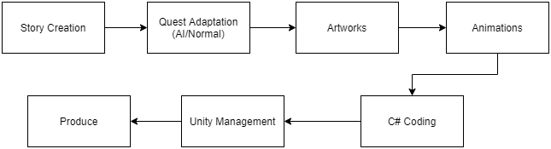 **Figure 6:** Workflow Scheme

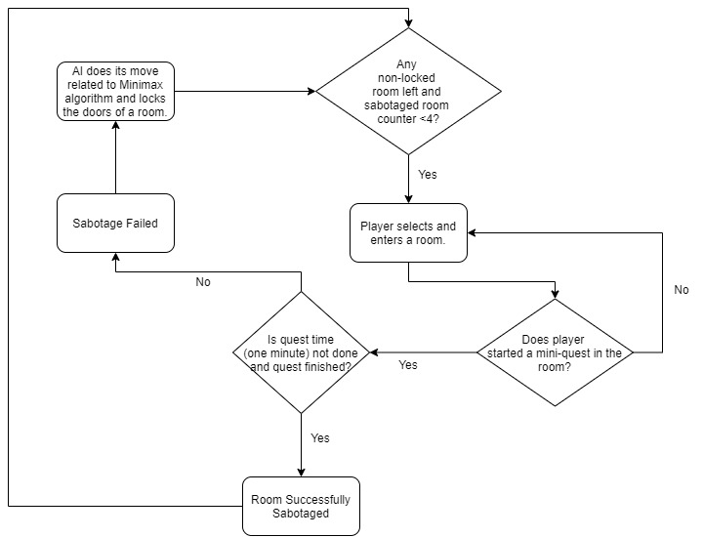 **Figure 7:** AI content flowchart

# DESIGN, IMPLEMENTATION AND TESTING

## Design

There are three main aspects of the project, and these are artworks, story, and artificial intelligence, all the things are set to satisfy the storyline. The first stage of creating a story is written and agreed upon by team members, and then with several meetings, some quests are designed to support the story, after all, the creation of artworks is started.

The artworks have four different aspects, they are character design, environment design, object design, and in-game animations, after a while from the start job share is assigned to members.

Ideas about artificial intelligence are shared between team members and with these ideas, some quest types are designed too.

## Implementation

The implementation is about unity aspects, which are coding and scene management. The first thing about coding is almost every object on the screen needs a script, like the movement of players, running animations, noticing about collusions, or dialogue management. Besides scripts scene management is also important because there is a story that needs to flow, to satisfy this condition each object needs to be in a harmony, also if something changes in a part of the map, that change must be permanent.

All artworks can be seen in the Appendix section.

## Testing

Lastly, after each script or scene design, its compatibility is tested by team members, and feedbacks are given to the designer. Feedbacks are the most important things in this part because for example artworks must be of the same quality, or the scenes should support each other.

# RESULTS

While doing these things, we found good models by watching lots of videos on YouTube and from different movies, games, and artworks. Since the first presentation teamwork was changed, the environmental design was assigned to Zeynep Ayyüce, the surrounding objects to Atakan, and the animations, coding, and integrity elements to Muhammed Rahmetullah. The idea behind the first period is to learn how to use Unity and Photoshop, to improve team skills, Artificial Intelligence and the rest of the story will be done in the upcoming period. The infrastructure for artificial intelligence tasks was prepared with the codes designed as the project progressed. By combining the designs in Unity, the story started to be formed. After that, the necessary scenes and animations for the story flow started to be created. On the other hand, additional games have begun to be coded for artificial intelligence tasks that we will use in the future. It will be associated with a nice bridge between the coded games and the project in the future.

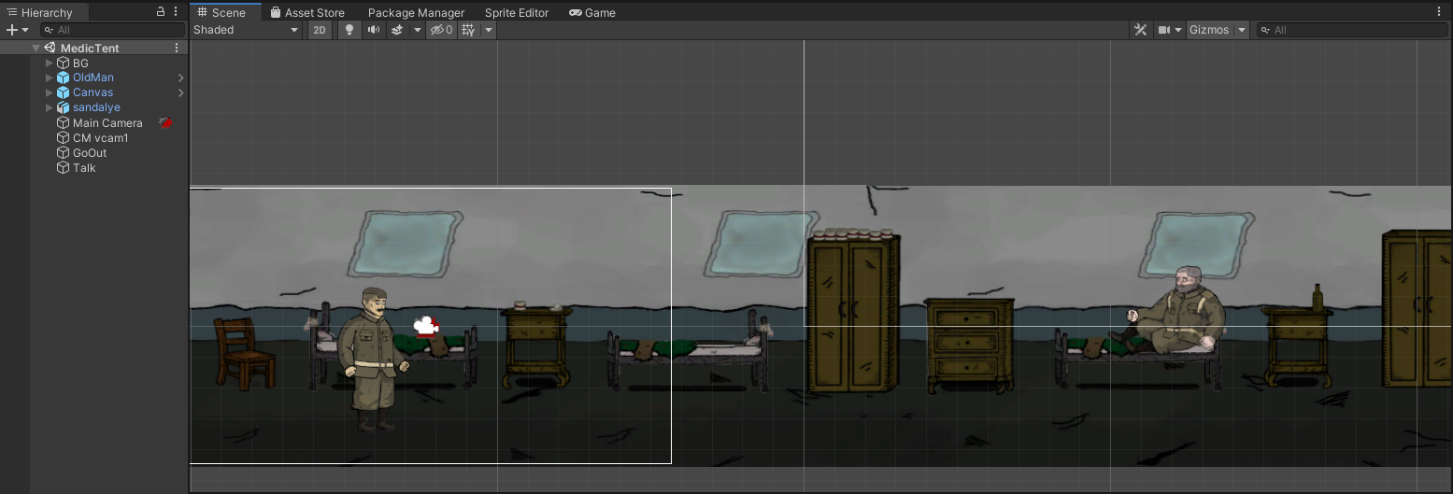

**Figure 8:** Medic Tent Scene

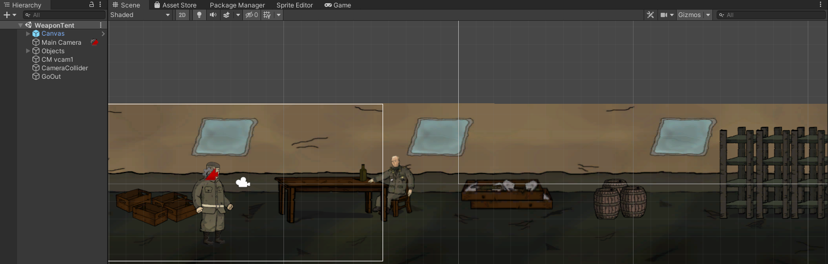

**Figure 9:** Weapon Tent Scene

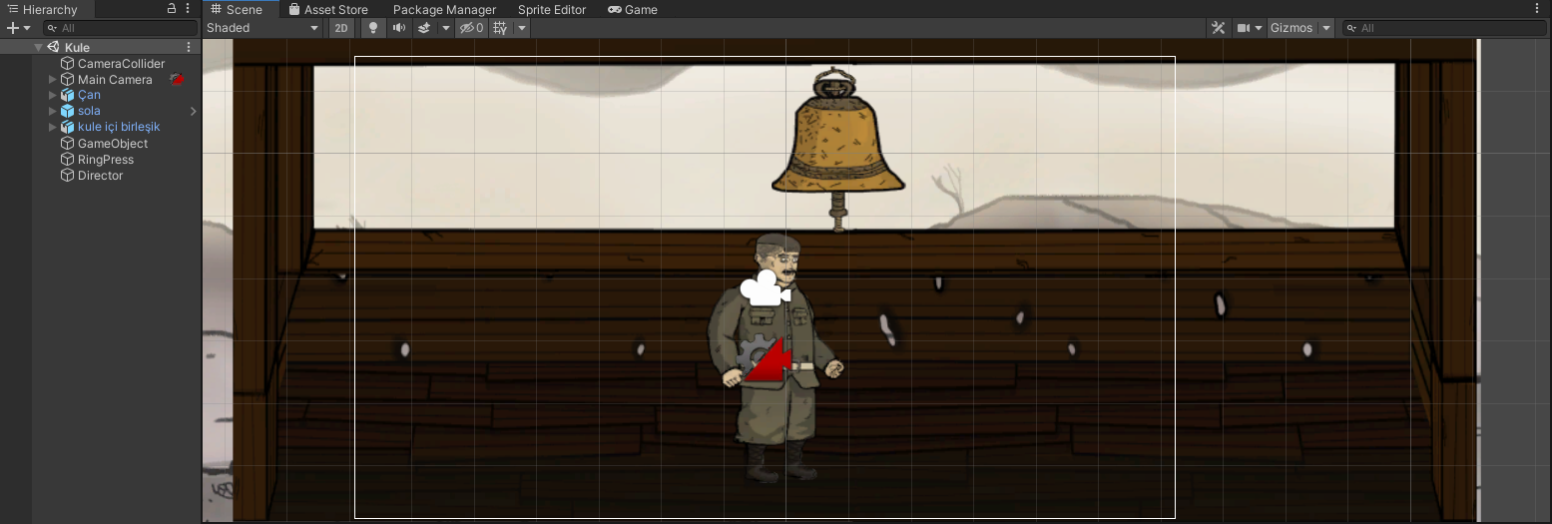

**Figure 10:** Tower Scene

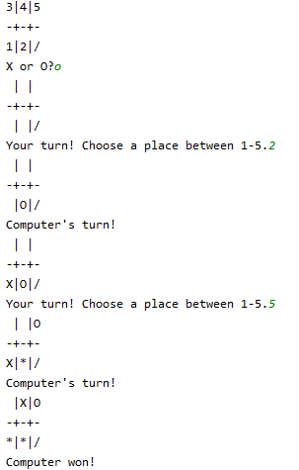

**Figure 11:** Output of 3x2 Isolation Game

You can have an idea about the current situation of the game in the figures above.

# CONCLUSION

## Lifelong Learning

While working on this project, the biggest advantage of all employees is that we learned about the programs that we did not have experience with and learned about these issues. By learning these programs, ourselves, we saw the problems encountered while accessing information and had the opportunity to improve ourselves on this issue. Additionally, we are gradually gaining the experience required for the game industry. Thus, when this project is finished, we will have gained experience on behalf of the sector, and we will be able to use the information and programs we have learned in other projects.

## Professional and Ethical Responsibilities of Engineers

In this process, it is the principle of professional reliability in our project. Another important principle is honesty. For example, in this project we have done, we emphasize that we only progress our drawings without any external element. If we want to follow this sentence, we must continue exactly like this. Because the principle of reliability is very important to us. Another important element is respect. We can exemplify this as follows. First, the members in the group respect each other. Then, in this project, we continue the project within this framework, respecting the social and social events.

## Contemporary Issues

The aim of this project is for the players to enjoy playing this game, thus making bad thoughts less prominent. The technologies we used in this project were not used until the last ten years. In the upcoming period, we think that these technologies will progress in a big way. Because this sector we have entered is one of the most active and fastest-growing sectors in the world. For this reason, the technologies we are using now may not be used next year. For example, maybe we will design the players we have designed in such a way that the time spent on the design process will gradually decrease.

## Teamwork

Teamwork was the biggest influence on this project. Knowledge of accountability, which is one of the variables in the development of this teamwork, is very crucial. They will not face a major problem if the individuals in a team meet their obligations.

Another significant concern is that individuals value one another. Since the first presentation teamwork was changed, the environmental design is assigned to Zeynep Ayyüce, the surrounding objects are assigned to Atakan, and the animations, coding, unity aspects are assigned to Muhammed Rahmetullah.

# REFERENCES

<https://en.wikipedia.org/wiki/Connect_Four> [1]

<https://brilliant.org/wiki/enigma-machine/#:~:text=An%20Enigma%20machine%20is%20a,time%20the%20code%20seemed%20unbreakable>. [2]

<https://en.wikipedia.org/wiki/Alpha%E2%80%93beta_pruning> [3]

[1]"Tic-tac-toe AI - Java Game Programming Case Study", *Www3.ntu.edu.sg*, 2021. [Online]. Available: https://www3.ntu.edu.sg/home/ehchua/programming/java/JavaGame_TicTacToe_AI.html. [Accessed: 21- Jan- 2021].

[2] N. Ramlagan and E. Tretkoff, "October 1958: Physicist Invents First Video Game", *Aps.org*, 2008. [Online]. Available: https://www.aps.org/publications/apsnews/200810/physicshistory.cfm#:~:text=In%20October%201958%2C%20Physicist%20William,Brookhaven%20National%20Laboratory%20open%20house. [Accessed: 21- Jan- 2021].

[3] "First use of cutscenes to tell a story in a videogame", *Guinness World Records*, 2021. [Online]. Available: https://www.guinnessworldrecords.com/world-records/first-use-of-cutscenes-to-tell-a-story-in-a-video-game#:~:text=The%20first%20example%20of%20a,by%20Nintendo%20in%20July%201981. [Accessed: 21- Jan- 2021].

[4] S. Xu, "History of AI design in video games and its development in RTS games", *Sites.google.com*, 2020. [Online]. Available: https://sites.google.com/site/myangelcafe/articles/history_ai. [Accessed: 21- Jan- 2021].

[5]"The Witcher 3: Wild Hunt", *Tr.wikipedia.org*, 2021. [Online]. Available: https://tr.wikipedia.org/wiki/The_Witcher_3:_Wild_Hunt. [Accessed: 21- Jan- 2021].

[6] T. Thompson, "The Perfect Organism: The AI of Alien: Isolation", *Gamasutra.com*, 2017. [Online]. Available: https://www.gamasutra.com/blogs/TommyThompson/20171031/308027/The_Perfect_Organism_The_AI_of_Alien_Isolation.php. [Accessed: 21- Jan- 2021].

# Appendix